WINE QUALITY PREDICTION
PREDICTTION

A PROJECT REPORT

Submitted by

Shivam Prasad (25BAI70897)

Kunal Verma (25BAI70432)

Lovenish Sharma (25BAI70632)

Akshit Sharma (25BAI70679)

Daksh Khatri (25BAI70806)

in partial fulfillment for the award of the degree of

Bachelors of Engineering
IN
Computer Science Engineering
(Artificial Intelligence & Machine Learning)


Chandigarh University
APRIL 2025



BONAFIDE CERTIFICATE

Certified that this project report “Wine Quality Predictor” is the Bonafide work of Shivam Prasad (25BAI70897), Kunal Verma (25BAI70432), Lovenish Sharma (25BAI70632), Akshit Sharma (25BAI70679) and Daksh Khatri (25BAI70806) who carried out the project work under my/our supervision.

SIGNATURE

Dr. Urvashi Garg

HEAD OF THE DEPARTMENT
Engineering Foundation 1

SIGNATURE

SUPERVISOR

Submitted for the project viva-voce examination held on

INTERNAL EXAMINER EXTERNAL EXAMINER

TABLE OF CONTENTS

List of Figures 5
List of Tables 7
List of Standards 8
CHAPTER 1. INTRODUCTION 12
  - Identification of Client/ Need/ Relevant Contemporary issue 12
Identification of Problem 12
  - Identification of Tasks 12
  - Timeline 12
  - Organization of the Report 13
CHAPTER 2. LITERATURE REVIEW/BACKGROUND STUDY 14
  - Timeline of the reported problem 14
  - Existing solutions 14
  - Bibliometric analysis 14
  - Review Summary 15
  - Problem Definition 15
  - Goals/Objectives 16
CHAPTER 3. DESIGN FLOW/PROCESS 17
  - Evaluation & Selection of Specifications/Features 17
  - Design Constraints 17
  - Analysis of Features and finalization subject to constraints 17
  - Design Flow 18
  - Design selection 18
  - Implementation plan/methodology 19
CHAPTER 4. RESULTS ANALYSIS AND VALIDATION 20
4.1. Implementation of solution 20
CHAPTER 5. CONCLUSION AND FUTURE WORK 21
  - Conclusion 21
  - Future work 21
REFERENCES 22
APPENDIX 23
- Plagiarism Report 23
- Design Checklist 23
USER MANUAL 24

List of Figures

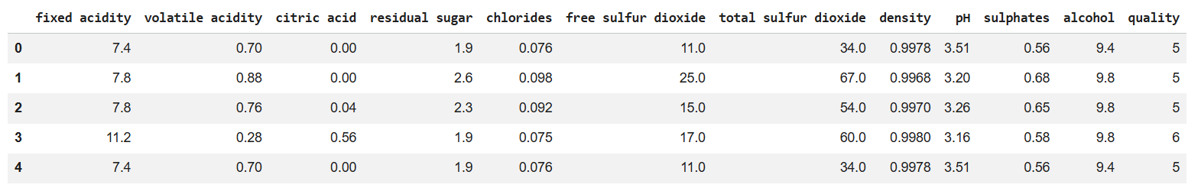Figure 1: Dataset Sample
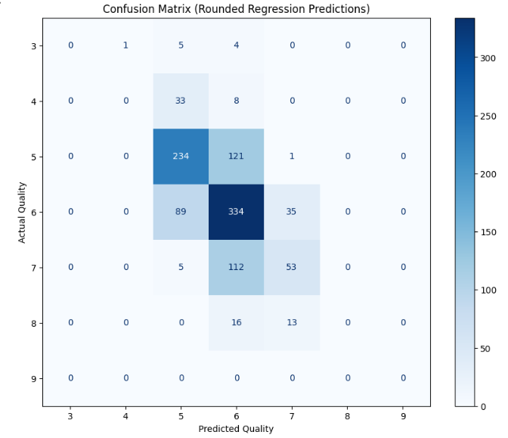
Figure 2: Confusion Matrix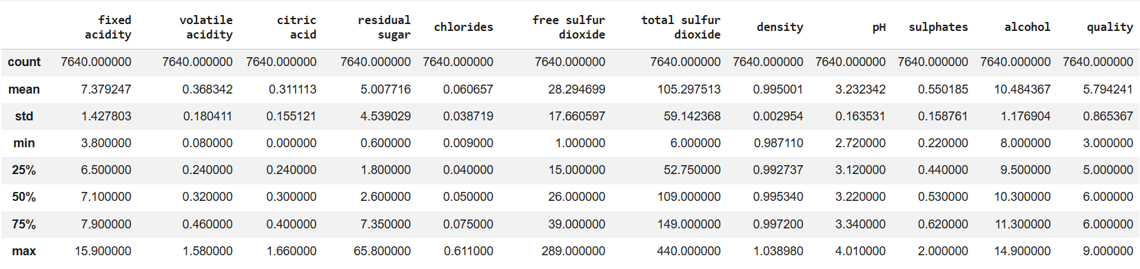 Figure 3: Statistical Summary

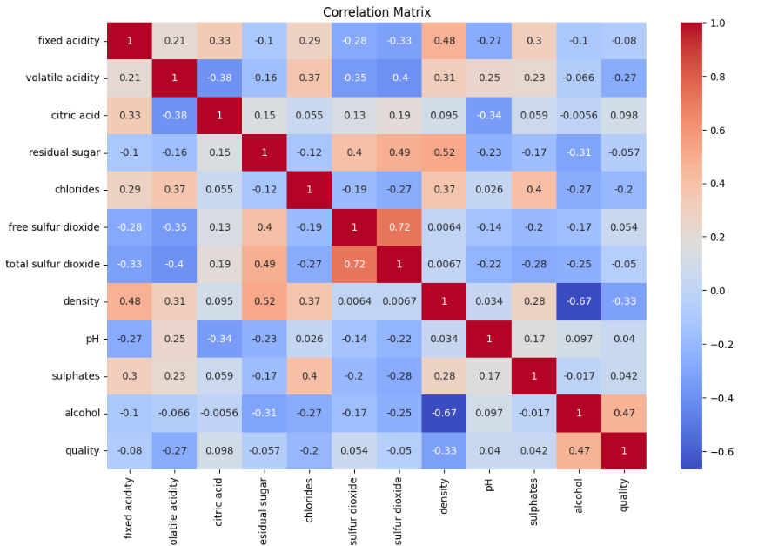
Figure 4: Correlation Matrix
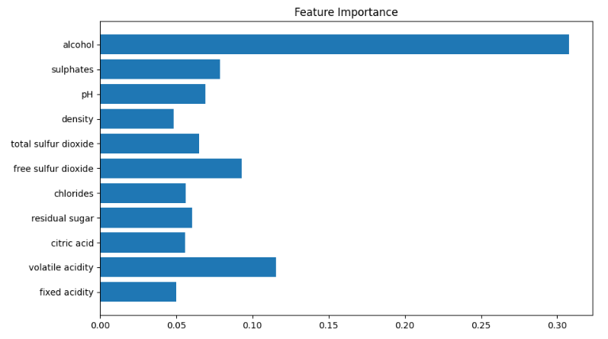
Figure 5: Feature Importance

Table 1: Dataset Overview
Property | Value
Number of Rows | 7640
Number of Columns | 12
Number of Features | 11
Target Variable | Quality

Table 2: Description of Features
Feature | Description
Fixed Acidity | Tartaric acid level
Volatile Acidity | Acetic acid level
Citric Acid | Freshness contributor
Residual Sugar | Remaining sugar
Chlorides | Salt content
Free Sulfur Dioxide | Preservative
Total Sulfur Dioxide | Overall SO₂
Density | Liquid density
pH | Acidity level
Sulphates | Additive
Alcohol | Alcohol content

Table 3: Class Distribution

Quality | Approx Distribution
Low (≤4) | Less
Medium (5–6) | Highest
High (≥7) | Less

List of Standards (Mandatory for Engineering Programs)

Standard | Publishing Agency | About the Standard | Page No
IEEE Machine Learning Standards | IEEE | Provides guidelines and best practices for implementing machine learning systems, ensuring reliability, accuracy, and ethical usage. | —
HTTP Protocol | IETF | Defines the communication protocol used between the web browser and Flask-based backend for data exchange. | —
JSON Format | ECMA | Standard data format used for sending and receiving structured data in the web application. | —

ABSTRACT

This project presents a full-stack Wine Quality Prediction System using Machine Learning, designed to automate and improve the process of wine quality evaluation. Traditionally, wine quality assessment relies on human experts, making it subjective and inconsistent. To address this, a machine learning-based system was developed using physicochemical properties such as acidity, alcohol content, and pH values.

The dataset was obtained from the UCI Machine Learning Repository and Kaggle, consisting of approximately 7600 samples and 11 features. Data preprocessing techniques including duplicate removal, scaling, and class imbalance handling were applied. A hybrid model approach was implemented using Random Forest Classifier for categorical prediction (Low/Medium/High) and Random Forest Regressor for numeric score prediction.

The system was deployed using a Flask-based backend and a modern web interface, allowing real-time user interaction. Additional features such as feature importance visualization were included to enhance interpretability. The model achieved reliable performance with an F1-score of approximately 0.55.

This project demonstrates the practical application of machine learning in building a scalable, user-friendly prediction system.

ABBREVIATIONS
Abbreviation | Full Form
ML | Machine Learning
AI | Artificial Intelligence
RF | Random Forest
UI | User Interface
API | Application Programming Interface
CSV | Comma Separated Values
EDA | Exploratory Data Analysis
F1 Score | Harmonic Mean of Precision and Recall
KNN | K-Nearest Neighbors
SVM | Support Vector Machine
NN | Neural Network
XGB | Extreme Gradient Boosting
SMOTE | Synthetic Minority Over-sampling Technique
HTTP | Hypertext Transfer Protocol
JSON | JavaScript Object Notation

SYMBOLS
Symbol | Meaning
X | Input Features (Wine chemical properties)
y | Target Variable (Wine Quality)
ŷ (y-hat) | Predicted Output
n | Number of Samples
f(x) | Model Function
μ | Mean of Data
σ | Standard Deviation
w | Model Weights
p | Probability

CHAPTER 1

INTRODUCTION

Identification of Need
Wine quality evaluation is traditionally performed by experts through sensory testing, which is subjective, time-consuming, and inconsistent. With the increasing demand for quality assurance in the wine industry, there is a need for an automated and data-driven solution.

Identification of Problem

The problem is to develop a system that can accurately predict wine quality based on physicochemical properties, reducing dependency on human evaluation.

Identification of Tasks

- Dataset collection and analysis
- Data preprocessing
- Model building and evaluation
- Web application development
- Deployment preparation

Timeline
Phase | Task | Duration
Phase 1 | Problem Identification & Idea Finalization | Week 1
Phase 2 | Dataset Collection & Understanding | Week 2
Phase 3 | Data Preprocessing & EDA | Week 3
Phase 4 | Model Building & Training | Week 4–5
Phase 5 | Model Evaluation & Improvement | Week 6
Phase 6 | Web Application Development (Frontend + Backend) | Week 7–8
Phase 7 | Integration & Testing | Week 9
Phase 8 | Report Preparation & Final Submission | Week 10

Organization of the Report

This report is structured into five chapters, each focusing on a specific aspect of the project:
- Chapter 1: Introduction
This chapter presents the background of the problem, identifies the need for the system, defines the problem statement, and outlines the objectives and tasks of the project.
- Chapter 2: Literature Review / Background Study
This chapter reviews existing research and solutions related to wine quality prediction, analyzes their approaches, and identifies gaps that motivate the proposed system.
- Chapter 3: Design Flow / Process
This chapter explains the methodology used in the project, including dataset preprocessing, feature selection, model design, and system architecture.
- Chapter 4: Results Analysis and Validation
This chapter presents the results obtained from the model, evaluates performance using metrics, and discusses the effectiveness of the system.
- Chapter 5: Conclusion and Future Work
This chapter summarizes the outcomes of the project and suggests possible improvements and future enhancements.

CHAPTER 2

LITERATURE REVIEW/BACKGROUND STUDY

Timeline of the reported problem

The problem of wine quality evaluation has evolved over time with advancements in technology:
- Pre-2000:
Wine quality assessment was entirely based on human sensory evaluation by experts (sommeliers), making it subjective and inconsistent.
- 2000–2010:
Introduction of physicochemical analysis, where laboratory measurements such as acidity, pH, and alcohol content were used to support quality assessment.
- 2010–2015:
Emergence of data-driven approaches, including basic statistical models and early machine learning techniques for predicting wine quality.
- 2015–2020:
Increased use of advanced machine learning algorithms such as Support Vector Machines, Neural Networks, and Random Forest, improving prediction accuracy.
- 2020–Present:
Focus shifted towards practical applications, including real-time prediction systems, web-based tools, and integration of machine learning models into user-friendly platforms.

Existing solutions

Traditionally, wine quality was evaluated using human sensory analysis, which is subjective and time-consuming. Later, physicochemical methods were introduced using measurable features like acidity, pH, and alcohol content.
With advancements in technology, various machine learning models such as Linear Regression, SVM, KNN, Neural Networks, and Random Forest have been used to predict wine quality more accurately.
However, most existing solutions focus only on model accuracy and lack real-time implementation, user interaction, and practical deployment as complete systems.

Bibliometric analysis

The existing literature on wine quality prediction focuses on analyzing different machine learning techniques based on their key features, effectiveness, and limitations.
- Key Features:
Most studies use physicochemical attributes such as acidity, pH, alcohol, and sulphates as input features. Feature selection techniques are often applied to identify the most influential parameters.
- Effectiveness:
Advanced models like Random Forest, Neural Networks, and XGBoost have shown higher accuracy due to their ability to capture non-linear relationships in the data.
- Drawbacks:
Many approaches suffer from issues such as class imbalance, overfitting, and lack of interpretability. Additionally, most solutions are limited to research environments and do not provide real-time, user-friendly systems.

Review Summary

The literature review highlights that machine learning techniques such as Random Forest, Neural Networks, and XGBoost are effective in predicting wine quality using physicochemical features. Feature selection and data preprocessing play a crucial role in improving model performance.
However, most existing studies are limited to model development and accuracy comparison, without focusing on real-time implementation or user interaction.
Based on these findings, the present project builds upon existing approaches by implementing a hybrid machine learning model that combines classification and regression. Additionally, it extends beyond traditional research by developing a web-based system that enables real-time prediction, making the solution more practical and user-friendly.

Problem Definition

The problem addressed in this project is to develop a system that can accurately predict wine quality based on its physicochemical properties, reducing dependency on subjective human evaluation.
The objective is to build a machine learning-based solution that takes input features such as acidity, pH, alcohol content, and other chemical attributes, and predicts the wine quality in both categorical form (Low/Medium/High) and numeric score (out of 10). This is achieved through proper data preprocessing, feature scaling, handling class imbalance, and training a hybrid model using Random Forest algorithms. The system is further integrated into a web-based application to enable real-time user interaction.
The project does not aim to replace expert sensory evaluation completely, nor does it involve advanced chemical experimentation or large-scale industrial deployment. It focuses on creating a data-driven, practical, and user-friendly prediction system using available datasets and standard machine learning techniques.

Goals/Objectives

The primary goals of this project are defined as measurable and specific milestones:
- To collect and analyze the wine quality dataset and understand the relationship between physicochemical features and quality.
- To preprocess the dataset by removing duplicates, handling imbalance, and applying feature scaling for improved model performance.
- To design and implement a hybrid machine learning model using Random Forest for both classification (Low/Medium/High) and regression (numeric score).
- To evaluate the model using performance metrics such as accuracy, F1-score, and confusion matrix.
- To develop a web-based application that allows users to input wine features and receive real-time predictions.
- To integrate the trained model into the backend using joblib for efficient deployment without retraining.
- To visualize important features influencing wine quality using feature importance techniques.

CHAPTER 3

DESIGN FLOW/PROCESS

Evaluation & Selection of Specifications/Features

Based on literature, physicochemical properties such as acidity, alcohol, pH, and sulphates are key factors influencing wine quality. These features were evaluated using statistical analysis and correlation techniques.
It was observed that features like alcohol, sulphates, and volatile acidity have a stronger impact on quality. However, all 11 features were retained to capture complete information and allow the model to learn complex relationships.
The final feature set includes all physicochemical attributes provided in the dataset, ensuring accurate and reliable prediction.

Design Constraints

The design of the system considers various standards and constraints:
- Regulatory & Ethical:
The project uses publicly available datasets and follows ethical practices in data usage without violating privacy or regulations.
- Economic:
The system is developed using open-source tools such as Python, Flask, and Scikit-learn, making it cost-effective.
- Environmental & Health:
The project is software-based and has no direct environmental or health impact.
- Safety:
The system does not involve any physical risks as it operates digitally.
- Professional & Social:
The system aims to improve decision-making in wine quality prediction, supporting consistency and reducing human bias.
- Cost:
Minimal cost is involved due to the use of freely available tools and datasets.

Analysis of Features and finalization subject to constraints

After evaluating the features and considering design constraints, the dataset was analyzed to ensure relevance and efficiency. Since all features are numerical, no major modifications were required.
No features were removed, as each contributes to the overall prediction. However, feature scaling was applied to handle differences in value ranges and improve model performance. Additionally, class imbalance was addressed to ensure fair learning across all categories.
Thus, the final feature set includes all original physicochemical attributes, properly scaled and optimized for model training.

Design Flow

Two alternative approaches were considered for solving the problem:
Approach 1: Single Model Approach
In this approach, a single machine learning model is used to directly predict wine quality as a numeric value. The predicted score can then be converted into categories (Low/Medium/High).
- Simple to implement
- Less computational complexity
- However, less accurate in handling class imbalance and category separation

Approach 2: Hybrid Model Approach (Selected)
In this approach, two models are used:
- Random Forest Classifier for predicting quality category (Low/Medium/High)
- Random Forest Regressor for predicting numeric score
This approach provides better accuracy and more meaningful outputs, as it handles both classification and regression separately.

Design Selection
The hybrid model approach was selected due to its improved performance, better handling of imbalanced data, and ability to provide both categorical and numeric predictions.

Design selection
Both approaches were analyzed based on performance, flexibility, and usability.
The Single Model Approach is simple and easy to implement, but it has limitations in accurately handling class imbalance and does not clearly differentiate between quality categories, leading to less reliable predictions.
In contrast, the Hybrid Model Approach provides better performance by separating classification and regression tasks. It improves prediction accuracy, handles class imbalance more effectively, and delivers both categorical and numeric outputs, making the system more practical and user-friendly.
Based on this comparison, the Hybrid Model Approach was selected as the final design due to its superior accuracy, flexibility, and real-world applicability.

Implementation plan/methodology

Flow Steps:
- User Input
User enters wine features (alcohol, pH, acidity, etc.)
- Data Preprocessing
Input validation
Feature scaling using StandardScaler
- Model Processing
Random Forest Classifier → predicts category
Random Forest Regressor → predicts score
- Prediction Output
Quality Category (Low/Medium/High)
Quality Score (e.g., 6.4/10)
- Display Result
Output shown on web interface

Algorithm
Step 1: Load dataset
Step 2: Preprocess data (remove duplicates, scaling, balancing)
Step 3: Define features (X) and target (y)
Step 4: Split dataset into training and testing sets
Step 5: Train Random Forest Classifier
Step 6: Train Random Forest Regressor
Step 7: Evaluate models using metrics (F1-score, confusion matrix)
Step 8: Save trained models using joblib
Step 9: Load model in Flask application
Step 10: Take user input and apply preprocessing
Step 11: Predict category and score
Step 12: Display results to user

CHAPTER 4

RESULTS ANALYSIS AND VALIDATION

Implementation of solution

The solution was implemented using modern tools and techniques across different stages:
- Analysis:
Data analysis and preprocessing were performed using Python (Pandas, NumPy) and visualization libraries such as Matplotlib and Seaborn.
- Design / System Architecture:
The system was designed as a web-based application with a frontend for user input and a backend using Flask, integrating the trained machine learning model.
- Model Development:
Machine learning models (Random Forest Classifier and Regressor) were implemented using Scikit-learn.
- Report Preparation:
The report was prepared using standard documentation tools such as MS Word.
- Project Management & Communication:
Version control and code management were handled using Git and GitHub, enabling efficient tracking and collaboration.
- Testing & Validation:
The model was evaluated using metrics such as F1-score and confusion matrix, and predictions were validated through multiple test inputs to ensure consistency and reliability.

CHAPTER 5

CONCLUSION AND FUTURE WORK

Conclusion

The project successfully achieved its objective of developing a machine learning-based system for predicting wine quality using physicochemical features. The system provides both categorical output (Low/Medium/High) and a numeric score, making it more informative and user-friendly.
The expected outcome was to build a reliable prediction model integrated with a web-based interface. The system performs consistently and demonstrates practical usability with an F1-score of approximately 0.55, which is acceptable given the complexity and imbalance of the dataset.
However, a deviation from the expected results was observed, as the model initially showed a tendency to predict medium quality more frequently. This occurred due to class imbalance in the dataset. The issue was addressed by applying balancing techniques and improving the model design, but some bias still remains.
Overall, the project demonstrates that machine learning can effectively automate wine quality prediction, though further improvements can enhance accuracy and robustness.

Future work

The current system can be further improved and extended in several ways:
- Model Improvement:
Implement advanced algorithms such as XGBoost, LightGBM, or deep learning models to improve prediction accuracy.
- Better Imbalance Handling:
Apply techniques like SMOTE or advanced class-weight tuning to further reduce bias toward medium-quality predictions.
- Larger Dataset:
Incorporate more diverse and larger datasets to improve generalization and robustness of the model.
- Feature Enhancement:
Include additional chemical or sensory features to better capture the complexity of wine quality.
- Deployment:
Deploy the application on cloud platforms for public access and scalability.
- User Interface Enhancement:
Improve UI/UX design with better visualization, dashboards, and interactive elements.

REFERENCES

- P. Cortez, A. Cerdeira, F. Almeida, T. Matos, and J. Reis, “Modeling wine preferences by data mining from physicochemical properties,” Decision Support Systems, vol. 47, no. 4, pp. 547–553, 2009.
- P. Bhardwaj, P. Tiwari, K. Olejar Jr., W. Parr, and D. Kulasiri, “A machine learning application in wine quality prediction,” Machine Learning with Applications, vol. 8, 100261, 2022.
- Y. Gupta, “Selection of important features and predicting wine quality using machine learning techniques,” Procedia Computer Science, vol. 125, pp. 305–312, 2018.
- S. Sharma et al., “ML-based predictive modelling for enhancement of wine quality,” Scientific Reports, vol. 13, 2023.
- P. Cortez, “Wine Quality Dataset,” UCI Machine Learning Repository, 2009.
- Kaggle, “Wine Quality Dataset,” Available online.

    - Plagiarism Report
The project report has been checked for plagiarism using standard plagiarism detection tools. The similarity index is within acceptable limits as per university guidelines. All external sources, including research papers, datasets, and references, have been properly cited to maintain academic integrity.
The content of this report is original and has been prepared solely for academic purposes. Any similarities found are due to commonly used technical terms or properly referenced material.

    - Design Checklist

S. No. | Task | Status
1 | Problem identification and objective definition | Completed
2 | Dataset collection and understanding | Completed
3 | Data preprocessing (cleaning, scaling, balancing) | Completed
4 | Feature selection and target definition | Completed
5 | Model selection (Random Forest) | Completed
6 | Model training and evaluation | Completed
7 | Implementation of hybrid model (classification + regression) | Completed
8 | Development of web application (frontend + backend) | Completed
9 | Integration of model with Flask API | Completed
10 | Testing and validation of system | Completed
11 | Feature importance analysis | Completed
12 | Report preparation and documentation | Completed

USER MANUAL

1. System Requirements
- Python (version 3.x)
- Required libraries: pandas, NumPy, scikit-learn, flask, matplotlib, seaborn
- Web browser (Chrome/Edge)

2. Installation Steps
- Install Python on your system
- Install required libraries using command:
pip install pandas NumPy scikit-learn flask matplotlib seaborn
- Download or clone the project files
- Ensure the trained model file (. joblib) is present in the project folder

3. Running the Application
- Open terminal / command prompt
- Navigate to project folder
- Run the Flask application:
python app.py
- Open browser and go to:
http://127.0.0.1:5000/

4. Using the System
- Enter wine feature values using sliders or input fields
- Click on “Predict” button
- View output:
  - Quality Category (Low/Medium/High)
  - Quality Score (e.g., 6.5/10)

5. Additional Features
- Feature importance visualization
- Input validation for correct ranges
- Real-time prediction

6. Screenshots to Add (IMPORTANT)
